ICT 2
Website:
www.zerobio.com/dichotomous_bugs.swf

Fill in the table below

Bug | Name
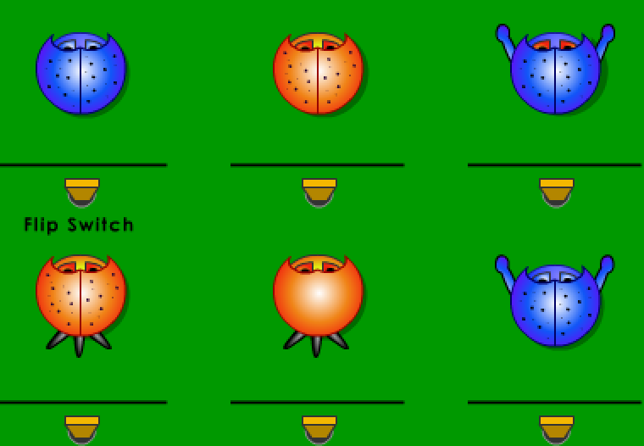 blue
orange
blue
orange
orange
blue

